PROPERTY RENTAL LISTINGS
@CREATIVITY THINK (9483175986/7019689991)

ABSTRACT:
Property Rental Listings is a web-based platform designed to connect property owners, agents, and potential tenants. Users can browse properties, apply search filters, contact owners, and track responses through a dashboard. Administrators manage listings, handle contact inquiries, and monitor analytics to improve platform efficiency. Built using Django and Django Rest Framework on the backend, with React, Leaflet, and Axios on the frontend, the system ensures secure data handling, real-time updates, and interactive mapping for property locations. This platform enhances rental discovery, communication, and management for users and administrators alike..

INTRODUCTION OF THE PROJECT:
Finding suitable rental properties and managing listings manually can be time-consuming. Property Rental Listings provides a web platform where users can filter, search, and contact property owners or agents, while administrators manage property listings and monitor user interactions through dashboards. Leveraging Django, DRF, React, Leaflet, and Axios, the platform offers secure, real-time, and interactive property management. It simplifies property discovery, enhances communication, and provides analytics-driven insights for administrators..

PROJECT OBJECTIVES:

• Allow users to search and filter available rental properties
• Enable users to contact property owners or agents directly
• Track inquiries and response status via dashboard
• Provide administrators tools to manage property listings
• Monitor contact forms and communications
• Generate dashboard analytics for insights on user engagement
• Ensure secure and interactive map-based property browsing

PROBLEM OF THE STATEMENT:
Users face difficulty finding suitable rental properties due to scattered listings, limited search tools, and lack of direct contact mechanisms. Property owners and agents struggle to manage inquiries efficiently. Administrators lack a unified dashboard for monitoring engagement and performance. This platform addresses these issues by centralizing property listings, enabling search and filter functionality, facilitating communication between users and property owners, and providing real-time analytics for administrators..

MOTIVATION OF THE PROJECT:
• Simplify property search and rental discovery for users
• Provide direct communication with property owners and agents
• Improve efficiency of property listing management for admins
• Offer analytics insights for better decision-making
• Enhance mapping visualization for property locations

BLOCK DAIGRAM OF PROJECT:

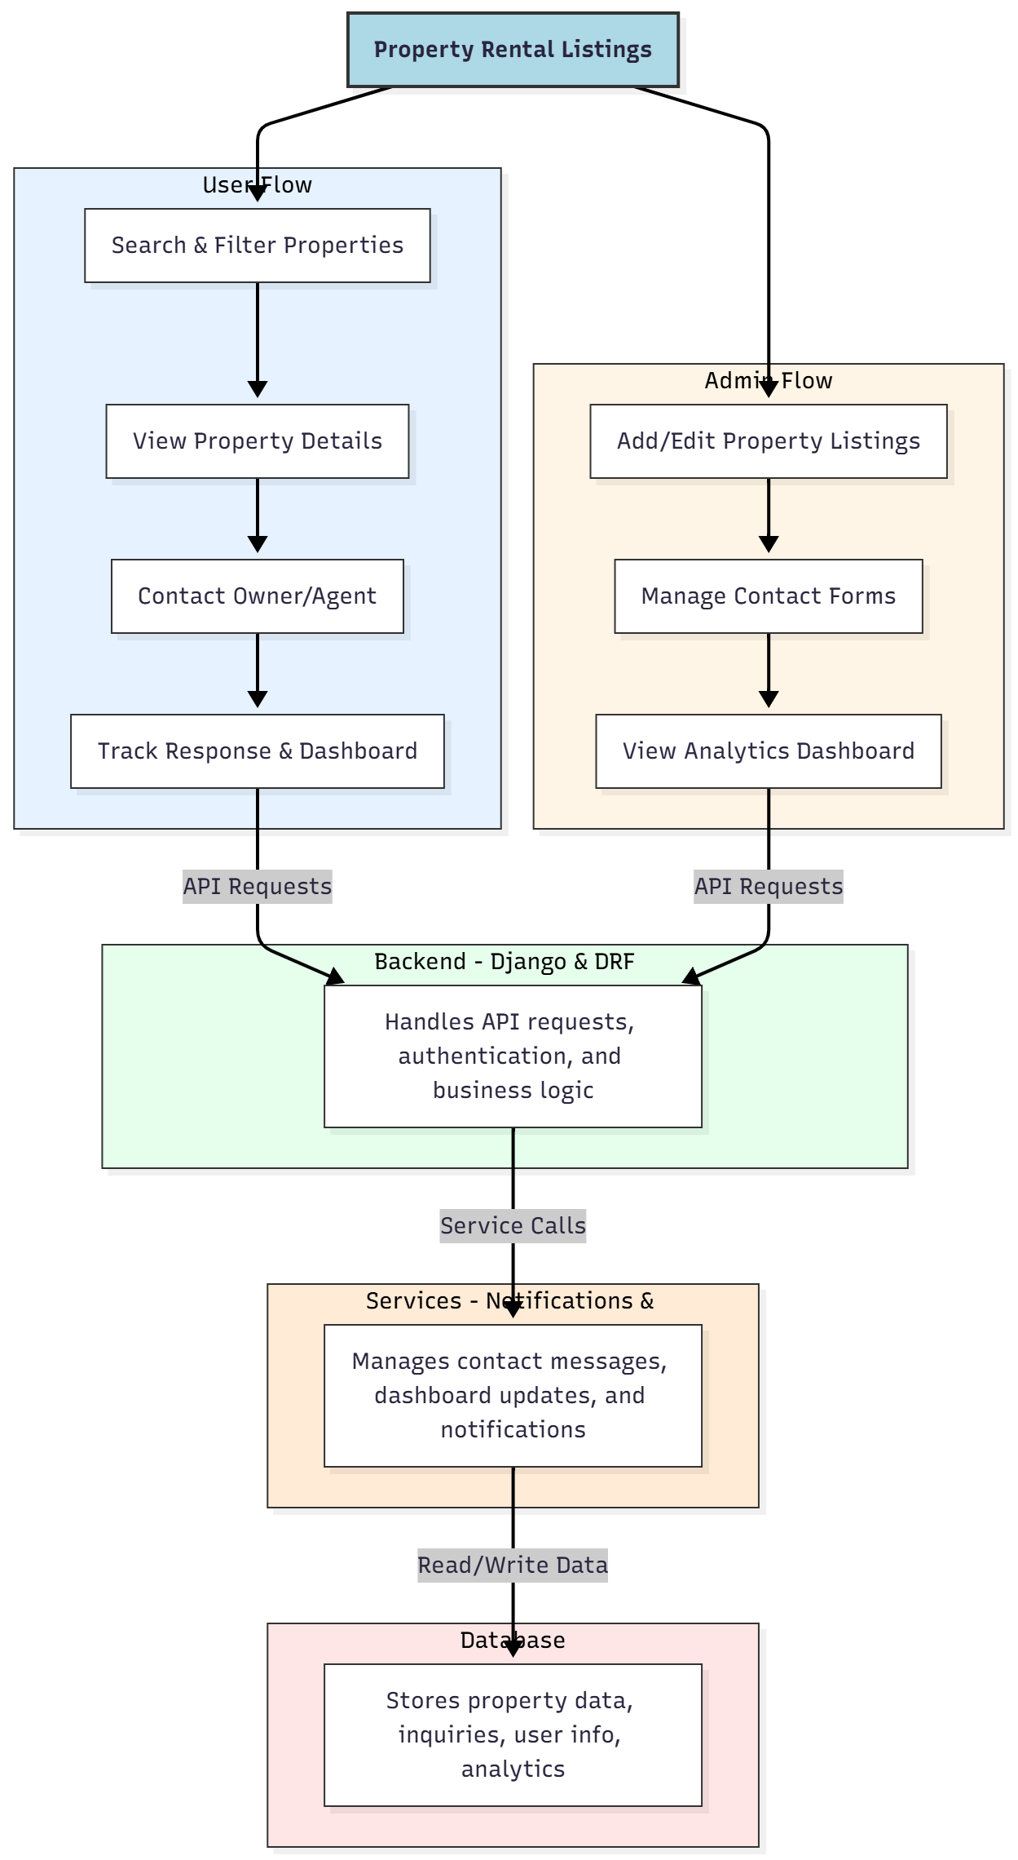

WORKING OF THE PROJECT:
Users log in and search for available rental properties using filters such as location, price, and type. They view property details, contact owners or agents, and track response status on the dashboard. The backend handles API requests, authentication, and business logic, while services manage notifications, inquiries, and dashboard updates. Administrators add or edit property listings, manage contact form submissions, and view analytics dashboards to monitor platform performance and engagement. This ensures a seamless rental search experience and efficient property management..

SOFTWARE REQUIREMENT:
- Backend:
  - Python 3.x
  - Django
  - Django REST Framework
  - SQLite/PostgreSQL
- Frontend:
  - Node.js and npm
  - React.js
  - Axios
- Development Tools:
  - Visual Studio Code
  - Postman (for testing APIs)
  - Git/GitHub (for version control)
- Server/Deployment (Optional):
  - Gunicorn, Nginx, or Heroku/AWS for hosting

ADVANTAGES OF THE PROJECT:

• Centralized property listing management
• Advanced search and filter for users
• Direct communication with property owners or agents
• Real-time dashboard analytics
• Easy management of inquiries and responses
• Secure and interactive map-based property visualization
• Efficient admin monitoring of platform activity
• Scalable web application for rental businesses

APPLICATIONS OF THE PROJECT:
• Property rental agencies and brokers
• Individual landlords managing multiple properties
• Real estate agents and consultants
• Online rental platforms
• Vacation rentals and Airbnb-style listings
• Student housing portals
• Commercial property rentals
• Analytics-driven property management

REFERENCES:

- Django REST Framework Documentation — Django Software Foundation. Django Documentation. Available: https://docs.djangoproject.com/
- Django REST Framework. DRF Documentation. Available: https://www.django-rest-framework.org/
- React. React Official Documentation. Available: https://reactjs.org/docs/getting-started.html
- Redux. Redux Documentation. Available: https://redux.js.org/introduction/getting-started
- PostgreSQL Global Development Group. PostgreSQL Documentation. Available: https://www.postgresql.org/docs/
- MySQL. MySQL Reference Manual. Available: https://dev.mysql.com/doc/
- Git. Git Documentation. Available: https://git-scm.com/doc
- Node.js. Node.js Documentation. Available: https://nodejs.org/en/docs/
- Axios. Axios Documentation. Available: https://axios-http.com/docs/intro
- Socket.io Documentation – https://socket.io/docs/

